Lab 10

Task 1:

Solution:

Master:

#include <Wire.h>

int x = 0;

void setup() {

// Start the I2C Bus as Master

Wire.begin();

pinMode(10,INPUT);

}

void loop() {

x = digitalRead(10);

Wire.beginTransmission(2); // transmit to device #2

Wire.write(x); // sends x

Wire.endTransmission(); // stop transmitting

}

Slave:

#include <Wire.h>

int LED = 13;

int x = 0;

void setup() {

// Define the LED pin as Output

pinMode (LED, OUTPUT);

// Start the I2C Bus as Slave on address 2

Wire.begin(2);

// Attach a function to trigger when something is received.

Wire.onReceive(receiveEvent);

}

void receiveEvent(int bytes) {

x = Wire.read(); // read one character from the I2C

}

void loop() {

//If value received is 0 blink LED for 200 ms

if (x == 1) {

digitalWrite(LED, HIGH);

}

else

{

digitalWrite(LED,LOW);

}

}

Output:

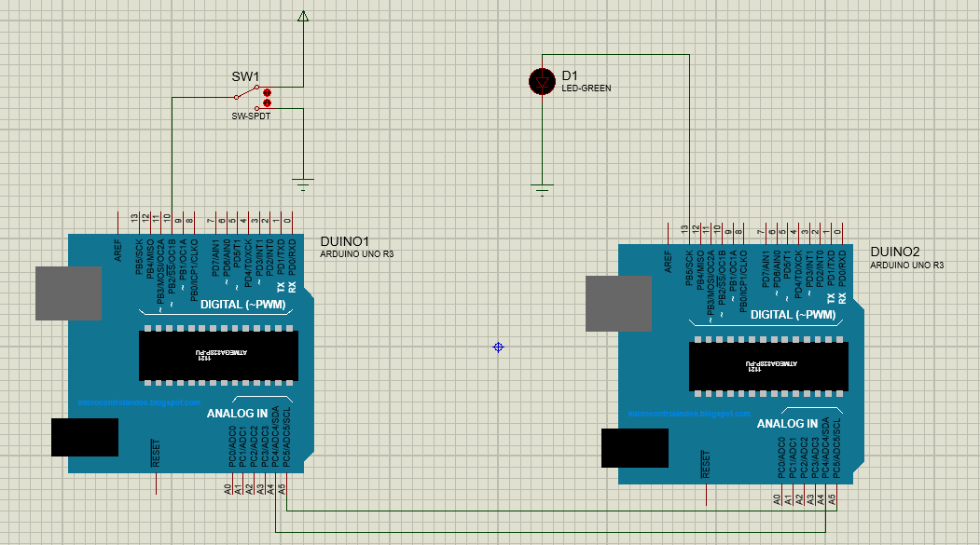

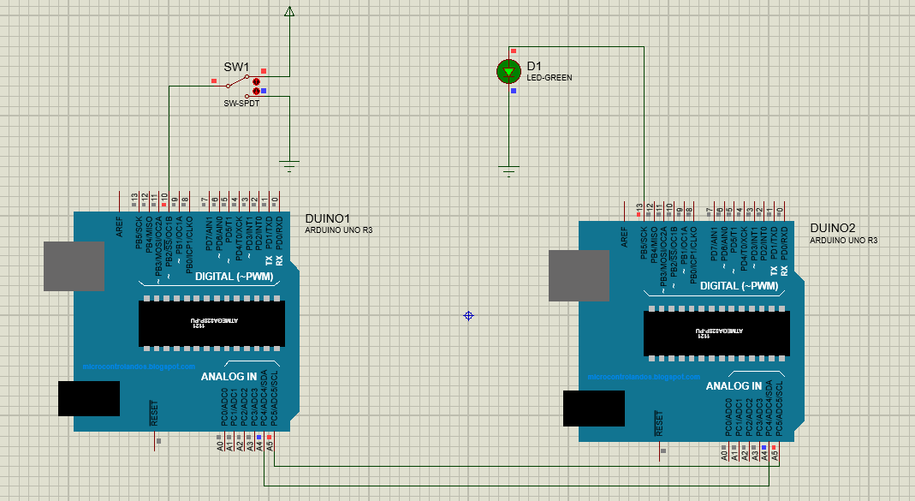

Task 2:

Solution:

Master:

#include <Wire.h>

#define ledPin 9

byte rcvData;

int potValue;

void setup()

{

Wire.begin();

rcvData = 255;

pinMode(ledPin, OUTPUT);

}

void loop()

{

potValue = analogRead(A0);

potValue = map(potValue, 0, 1023, 0, 255);

Wire.beginTransmission(0x14);

Wire.write(potValue);

Wire.endTransmission();

Wire.requestFrom(0x14, 1);

if(Wire.available())

{

rcvData = Wire.read();

}

analogWrite(ledPin, rcvData);

}

Slave:

#include <Wire.h>

#define ledPin 9

byte rcvData;

int potValue;

void setup()

{

Wire.begin(0x14);

/\*Event Handlers\*/

Wire.onReceive(DataReceive);

Wire.onRequest(DataRequest);

rcvData = 255;

pinMode(ledPin, OUTPUT);

}

void loop()

{

potValue = analogRead(A0);

potValue = map(potValue, 0, 1023, 0, 255);

analogWrite(ledPin, rcvData);

}

void DataReceive(int numBytes)

{

while(Wire.available())

{

rcvData = Wire.read();

}

}

void DataRequest()

{

Wire.write(potValue);

}

Output:

